503IT Communication and Collaboration
Week 2 Session 1 - First 4 Hours Revised Student Activity
UX Concept Development, Game Research, Canvas Upgrade and Storyboard Upgrade
Module | 503IT | Class | Group E
Session | Week 2 Session 1 | Duration | First 4 hours
Important message for students
Today you are not only decorating the game. You are improving the player experience. You must decide what the user sees, how the user plays, what the background looks like, what icons/buttons/characters are used, how feedback is shown, and how the game helps the user learn cyber safety. You must upgrade last week’s Game Concept Canvas and Storyboard into a stronger UX-focused version.

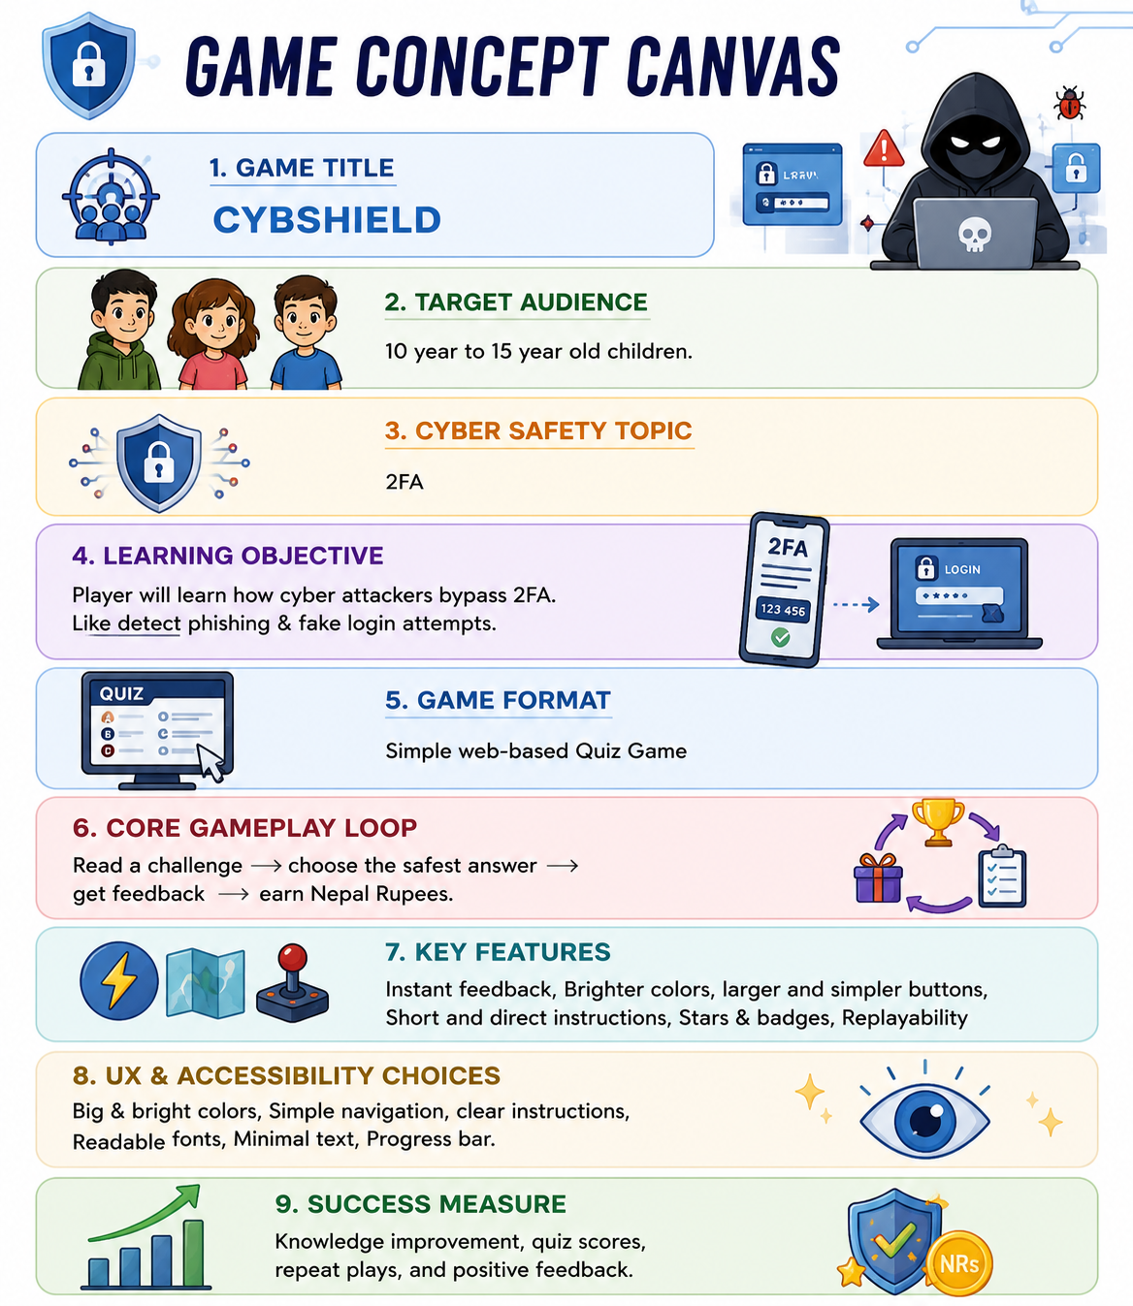
Sample visual direction: one UX-focused Game Concept Canvas and one 6-frame storyboard for a 10-year-old target audience.

1. What students are doing in the first 4 hours
The first 4 hours are about developing the UX concept for the group’s cyber-safety game. Students should not simply create a pretty poster. They must think like a real user and explain how the game will be experienced.
By the end of this session, each group should be able to answer:
- What will the player see when the game starts?
- How will the player know what to do?
- What background, colours, icons, buttons and characters will be used?
- How will the player move from one screen or stage to the next?
- How will the game give feedback after correct or incorrect answers?
- How will the game be accessible and suitable for the chosen target audience?
- How did examples from existing games influence the design choices?
- What exactly has been upgraded from last week’s canvas and storyboard?

2. Tools students must use today
Tool | Used for | How students should use it | Final evidence
GitHub | Evidence storage and contribution tracking | Create the Week-2-Session-1 folder, create written files, upload final PDFs, and commit changes with clear messages. | Repository folders, files, commits and upload history
Canva | Preferred tool for visual design | Create or upgrade the Game Concept Canvas and Storyboard using templates, icons, colour palettes, large text and visual layout. | PDF exports: updated-game-concept-canvas.pdf and updated-storyboard.pdf
PowerPoint | Backup visual design tool | Use slides, shapes, icons and text boxes if Canva does not work. Export the finished canvas/storyboard as PDF. | PDF exports uploaded to GitHub
Web browser | Research existing games/apps | Find 2 existing child-friendly educational games, cyber-safety games, quiz games or interactive learning apps and identify how they attract and hold users. | game-ux-research.md
Worksheet / notes | Planning before final design | Discuss as a group and fill in the tables before producing final Canva/PowerPoint artefacts. | Completed written evidence and individual contribution logs

3. What they are upgrading from last week
Last week, students created the first draft of their Game Concept Canvas and Storyboard. Today they must upgrade those drafts. They should not start from zero unless last week’s work is missing or too weak.
Last week’s draft | Today’s upgrade | What should improve
Game Concept Canvas | Final UX-focused Game Concept Canvas | Clearer target audience, stronger learning objective, detailed UX choices, accessibility choices, rewards and success measure
Storyboard / storytelling flow | Final 6-frame UX storyboard | Better screen flow, clearer player choices, better feedback, child-friendly visuals, icons, buttons and background
Initial game idea | Improved game concept notes | Evidence of what changed and why
Group discussion | Meeting 03 minutes and contribution logs | Evidence of collaboration, decisions and individual work

4. First 4-hour session plan
Time | Activity | What students do | Evidence to upload
0:00-0:20 | Project and GitHub check-in | Open last week’s GitHub repository, check Day 1 and Day 2 evidence, check canvas/storyboard availability. | No new file yet; tutor checks progress
0:20-0:45 | UX and accessibility briefing | Understand UX, accessibility, inclusive design, gameplay flow, feedback and child-friendly design. | Notes for later files
0:45-1:25 | Existing game UX research | Find and analyse 2 existing games/apps/learning tools to identify how they attract and hold users. | game-ux-research.md
1:25-2:05 | UX concept decisions | Decide game look, background, icons, characters, buttons, instructions, feedback, rewards and accessibility choices. | ux-accessibility-review.md
2:05-2:50 | Upgrade Game Concept Canvas | Use Canva/PowerPoint to upgrade last week’s canvas into a final UX-focused canvas. | updated-game-concept-canvas.pdf
2:50-3:30 | Upgrade Storyboard | Create a 6-frame storyboard showing exactly how the player starts, plays, chooses, receives feedback and learns. | updated-storyboard.pdf
3:30-3:50 | Presentation practice | Each member prepares a short explanation of one UX improvement. Group prepares a short progress update. | presentation-practice-reflection.md
3:50-4:00 | Final upload and checklist | Upload files, check commits, update contribution logs and complete checklist. | meeting-03-minutes.md and contribution logs

5. Step-by-step student instructions

Step 1: Open your GitHub repository
1. Open GitHub in a web browser and sign in.
2. Open your group repository created last week.
3. Check that Day-1-Group-Formation and Day-2-Concept-Development folders exist.
4. Check that last week’s canvas and storyboard are available. If they were not uploaded, upload them first as evidence.
5. One group member should create today’s folder: Week-2-Session-1-UX-Accessibility.
GitHub folder for today
Create this folder by creating a file inside it. Example file path: Week-2-Session-1-UX-Accessibility/game-ux-research.md. The slash creates the folder.

Step 2: Research existing games or learning apps before designing
Because this is Year 2 work, students must not only guess what looks good. They should look at existing examples and learn from them. They are not copying designs. They are studying how good games attract and hold users.
Each group must find at least 2 examples. They can be educational games, cyber-safety games, quiz games, children’s learning apps, interactive stories, or child-friendly web games.

What to look for during research
- What colours are used and why might they attract the user?
- What type of background is used: classroom, adventure map, cyber world, cartoon world, simple quiz screen?
- What icons are used: lock, shield, warning sign, star, email, key, trophy, badge?
- How does the game explain instructions?
- How does the game make the user continue playing?
- Does the game use points, stars, badges, levels, timers or progress bars?
- What feedback does the user receive after a choice?
- Is the text large and readable?
- Is the design suitable for the target age group?
- What accessibility features or inclusive choices can you notice?

Create this GitHub file
File path: Week-2-Session-1-UX-Accessibility/game-ux-research.md
Example game/app | Target user | Colours/background | Icons/buttons | How it holds attention | Feedback/reward system | What we will apply
duolingo | 13-30 | Green/grey | Large bright colors/ stars, shields etc. | Streaks, xp points, short lessons, positive feedback | Badges, unlockables, celebratory animations | Educational ux and motivation
Among us | 10-25 | Dark navy/ green | Bold simple/ arrows | Suspense, missions, uncertainty | Social achievement, match completion satisfaction | Gameplay, suspense and mission designs
Commit message: Add UX research from existing games

Step 3: Decide the UX concept for your own game
After research, students must make clear design decisions for their own game. This is the main task today.

Students must decide the following UX details
UX decision area | What students must decide | Example for 10-year-old users
Visual style | What the game should look like overall. | Bright, friendly, cartoon-style cyber adventure
Background | What background appears on screens. | Digital classroom, safe cyber world, simple quiz screen, adventure map
Colours | What colours support readability and mood. | Blue for safety, green for correct, orange/red for warning, high contrast
Icons | What visual symbols help understanding. | Lock, shield, email, warning triangle, star, badge, key
Characters | Whether a guide or avatar helps the player. | Cyber safety robot or student hero gives guidance
Buttons | How choices are shown. | Large rounded buttons with short text and icons
Instructions | How the player learns how to play. | 3-4 simple steps before the first challenge
Feedback | What happens after each answer. | Correct/incorrect message plus a short learning explanation
Rewards | How the player is encouraged to continue. | Stars, badges, progress bar, level unlocks
Accessibility | How barriers are reduced. | Large font, simple language, high contrast, icons, no scary images

Create this GitHub file
File path: Week-2-Session-1-UX-Accessibility/ux-accessibility-review.md
Question | Group answer | Improvement needed?
Is the game easy to understand for the target audience? | Yes, the game uses simple instructions, bright colors and easy choices suitable for 10-year-old users. | Add more visual examples before gameplay starts.
What will the player see on the first screen? | The player will see the game title, a friendly cyber-safety robot, a Start Game button and colorful background graphics. | Add a short welcome message explaining the game goal.
Are the instructions clear before gameplay starts? | Yes. Instructions are shown in 3 simple steps with icons and short action words. | Make instruction text larger for readability.
Are the colours, fonts and buttons readable? | Yes. The game uses high-contrast colors, large, rounded buttons and simple fonts. | Improve spacing between buttons for easier clicking.
What icons or characters will help the player understand? | Lock, shield, warning sign, email icon and a robot guide character will help users understand the game. | Add labels below some icons for extra clarity.
How will the game show correct or incorrect answers? | Correct answers show a green tick and positive message. Incorrect answers show a warning message with explanation. | Add sound effects and animations for feedback.
How will feedback teach the cyber-safety lesson? | Feedback explains why the answer is safe or unsafe and gives a short cyber-safety tip. | Add examples from real online situations.
How will the design support users with different learning needs? | The game uses simple language, visual icons, large text and clear layouts to support different learners. | Add optional voice instructions in future versions.
What three UX/accessibility improvements will we make today? | 1. Increase button size. 2. Improve color contrast. 3. Add clearer instructions with icons. | Continue testing with target users for more improvements.
Commit message: Add UX and accessibility review

Step 4: Upgrade the Game Concept Canvas
Students should open last week’s Game Concept Canvas and improve it using Canva or PowerPoint. The new version should look more professional and should explain the UX choices clearly.

Tool instructions: Canva
1. Open Canva and sign in.
2. Search for poster, whiteboard, infographic, game design, storyboard or concept map templates.
3. Choose a clean template with boxes or sections.
4. Use large readable text and consistent colours.
5. Add icons such as lock, shield, email, star, badge, warning sign or key.
6. Add the required canvas sections below.
7. Export the final design as PDF.
8. Upload the PDF to GitHub.

Tool instructions: PowerPoint backup
1. Open PowerPoint and create a blank slide.
2. Use rectangles and text boxes to make a one-page canvas.
3. Use Insert > Icons or Insert > Shapes for visual symbols.
4. Use large fonts and consistent colours.
5. Save or export as PDF.
6. Upload the PDF to GitHub.

Required sections in the upgraded canvas
Canvas section | What to include | Quality expectation
Game title | Final or working name of the game. | Clear, memorable and suitable for the target audience
Target audience | Exact user group, age and context. | Not just "children" - be specific, e.g., 10-year-old children
Cyber-safety topic | The online safety issue being taught. | Phishing, passwords, online privacy, cyberbullying, scams or safe gaming
Learning objective | What the player should learn by playing. | Measurable and linked to cyber safety
Game format | Web game, quiz, card game, board game, app mock-up, Twine story, Scratch game, etc. | Realistic for the team and time available
Core gameplay loop | What the player repeatedly does. | Example: read challenge -> choose answer -> receive feedback -> earn reward
UX design choices | Colours, layout, buttons, background, icons and characters. | Clearly justified based on target audience
Accessibility choices | Large text, simple words, contrast, icons, clear feedback, inclusive visuals. | Specific choices, not vague statements
Reward and motivation | Stars, badges, points, level progress or positive messages. | Explains how the game keeps the user engaged
Success measure | How the group will know the user learned something. | Example: answer 5 questions and explain 3 safety rules
Final file name: updated-game-concept-canvas.pdf
Upload location: Week-2-Session-1-UX-Accessibility/updated-game-concept-canvas.pdf
Commit message: Upload updated UX-focused game concept canvas

Step 5: Upgrade the Storyboard
The storyboard should show the player journey. It must show what the user sees and does from the start of the game to the learning outcome. It should not only describe the story; it should show the screen flow.
Frame | What to show | UX details to include | Example for 10-year-old target audience
1 | Welcome/start screen | Game title, friendly guide/character, start button | Cyber Safety Quest with a Start Game button
2 | Instructions | Short steps, icons, clear action words | Read the challenge, choose the safest answer, get feedback, earn a star
3 | First challenge | Cyber-safety scenario, background, message or problem | You won a prize! Click here now.
4 | Player choice | Large answer buttons, clear options, no confusing text | Click it / Ignore it / Ask a trusted adult
5 | Feedback | Correct/incorrect response plus learning explanation | Correct: suspicious links can be unsafe
6 | Reward/learning summary | Score, badge, star or key lesson summary | You earned a Cyber Safety Star. Think before you click.
Final file name: updated-storyboard.pdf
Upload location: Week-2-Session-1-UX-Accessibility/updated-storyboard.pdf
Commit message: Upload updated UX storyboard

Step 6: Explain what changed and why
Students must create a written explanation of the improvements. This prevents the work from becoming only visual design. The group must show critical thinking.
File path: Week-2-Session-1-UX-Accessibility/improved-game-concept-notes.md
Area | Original idea | Improved idea | Reason for improvement
Instructions | Text-only instructions | Step-by-step visual tutorial with icons | Easier for younger users to understand
Visual style/background | Basic quiz layout | Futuristic cyber-themed cartoon world | Makes learning more engaging
Icons/buttons | Small simple buttons | Large colorful rounded buttons with icons | Better readability and accessibility
Feedback system | Correct/incorrect only | Animated feedback with explanations | Helps users learn from mistakes
Accessibility | Standard text | High contrast colors and simple language | Supports younger users and different learning needs
Reward system | Simple score counter | XP points, badges, streaks and unlockables | Keeps users motivated and engaged
Commit message: Add improved game concept notes

Step 7: Presentation practice
Each student prepares a 30-second explanation of one UX improvement. This supports the final group presentation later in the module.
Speaking prompt | Student notes
My name is... | My name is Misha Tamang
Today our group improved... | Today our group improved the UX design and accessibility of CybShield.
Before, the problem was... | Before, the game looked too simple and lacked clear feedback.
We changed it by... | We changed it by adding better colors, icons, animations and rewards.
This improves the game because... | This improves the game because younger users can understand and enjoy it more easily.
This will help our target users because... | This will help users aged 10–15 learn cybersecurity in a fun and interactive way.
File path: Week-2-Session-1-UX-Accessibility/presentation-practice-reflection.md
Commit message: Add presentation practice reflection

Step 8: Meeting minutes and individual contribution logs
One student should create meeting minutes for today. Every student should update their own contribution log.
File | What to include
Week-2-Session-1-UX-Accessibility/meeting-03-minutes.md | Date, chair, minute-taker, attendees, agenda, UX decisions, canvas/storyboard decisions, action plan
Individual-Contribution-Logs/student-name-contribution.md | What I did today, which file I created/edited, what I learned about UX/accessibility, commit message

6. What must be uploaded to GitHub by the end of the first 4 hours
Task | Evidence to show | Done? (Y/N) | Group member responsible
Create today’s folder | Week-2-Session-1-UX-Accessibility/ | Done | Misha Tamang
Research existing games/apps | game-ux-research.md | Done | Yosheph Tamang
Review UX and accessibility | ux-accessibility-review.md | Done | Yosheph Tamang
Explain improvements | improved-game-concept-notes.md | Done | All members
Upload final canvas | updated-game-concept-canvas.pdf | Done | Pawan Sunar
Upload final storyboard | updated-storyboard.pdf | Done | Priksha Rawat
Record meeting evidence | meeting-03-minutes.md | Done | Krishna Sah
Practise speaking | presentation-practice-reflection.md | Done | Misha Tamang
Update individual evidence | Individual-Contribution-Logs/student-name-contribution.md | Done | All members

7. Final mini output before break
Before the break, each group should be ready to briefly show the tutor:
- the updated Game Concept Canvas
- the updated 6-frame Storyboard
- the UX research notes from at least 2 examples
- the UX/accessibility review file
- the GitHub folder and commit history
- which student completed which contribution.
Tutor prompt for students
Show me your updated canvas and storyboard. Explain one thing you changed because of UX/accessibility. Then show me the GitHub commit that proves the update was uploaded.

8. Completion checklist with group member details
Complete this checklist before the end of the first 4-hour session. Every student must have a visible contribution.
Student name | Student ID | GitHub username |  | Main task completed today | Commit message | Signature
Pawan Sunar | 16084658 | Pawan Sunar | Canvas design |  | Overall canva look
Misha Tamang | 15304863 | Misha Tamang | Presentation practice/ github |  | Practiced the presentation and created the GitHub File
Yosheph Tamang | 15614717 | Yosheph Tamang | Game research |  | Researched 2 types of games( Duolingo & among Us)
Priksha Rawat | 15659132 | Priksha Rawat | Storyboard improvement |  | Improved the storyboard
Krishna Sah | 15635480 | Krishna Sah44 | Research help |  | Helped the members with the research

Group task completion checklist
Task | Evidence to show | Done? (Y/N) | Group member responsible
GitHub repository opened and checked | Group can show the repository | Done | Misha Tamang
Week-2-Session-1 folder created | Folder exists in GitHub | Done | Misha Tamang
At least 2 existing games/apps researched | game-ux-research.md completed | Done | Yosheph Tamang
UX and accessibility review completed | ux-accessibility-review.md completed | Done | Yosheph Tamang
Game look/background/icons/buttons/characters decided | Written in review or concept notes | Done | Pawan Sunar
Last week’s canvas upgraded | updated-game-concept-canvas.pdf uploaded | Done | Pawan Sunar
Last week’s storyboard upgraded | updated-storyboard.pdf uploaded | Done | Priksha Rawat
Improvement explanation completed | improved-game-concept-notes.md completed | Done | Pawan Sunar
Meeting 03 minutes uploaded | meeting-03-minutes.md uploaded | Done | Krishna Sah
Presentation practice reflection uploaded | presentation-practice-reflection.md uploaded | Done | Misha Tamang
Every student updated contribution log | Individual contribution files updated | Done | All
Every student has at least one visible commit | Commit history shows all members | Done | all

9. Tutor delivery notes
Use this section to explain the activity clearly before students begin independent work.

What to say at the start
Today you are upgrading your project from an idea into a user experience design. Last week you produced a first canvas and storyboard. Today you must improve them by thinking about the real player. If your game is for 10-year-old children, you must decide what they see, what they click, what background and icons they understand, what feedback they receive, and how the game keeps them engaged. You must also research at least two existing games or learning apps and use that research to justify your own design choices.

Questions to ask while walking around
- Which existing game or app inspired your UX choices?
- What will the player see on the first screen?
- How will the player know what to do without tutor explanation?
- What background, icons and buttons are you using and why?
- What feedback does the player receive after a wrong choice?
- How is the game suitable for your target age group?
- What did you change from last week’s canvas or storyboard?
- Where is the GitHub evidence for this work?
- Which student made this commit?

Tutor quick monitoring table
Group | Research done | UX review | Canvas upgraded | Storyboard upgraded | GitHub upload | All students committed | Notes
Group 1
Group 2
Group 3
Group 4
Group 5
Group 6
Group 7
Group 8

